**[Design Phase](https://www.britannica.com/technology/artificial-intelligence)**



Supervisor

Dr. Zahid Mehmood Akash

**Submitted by**

Muhammad Naseer, Amna Naseer

10,42

**Session 2021-2025**

**Department of CS&IT**

**Faculty of Computing & Engineering**

**University of Kotli Azad Jammu and Kashmir**

**Use-case Diagram E-LaborBridge**

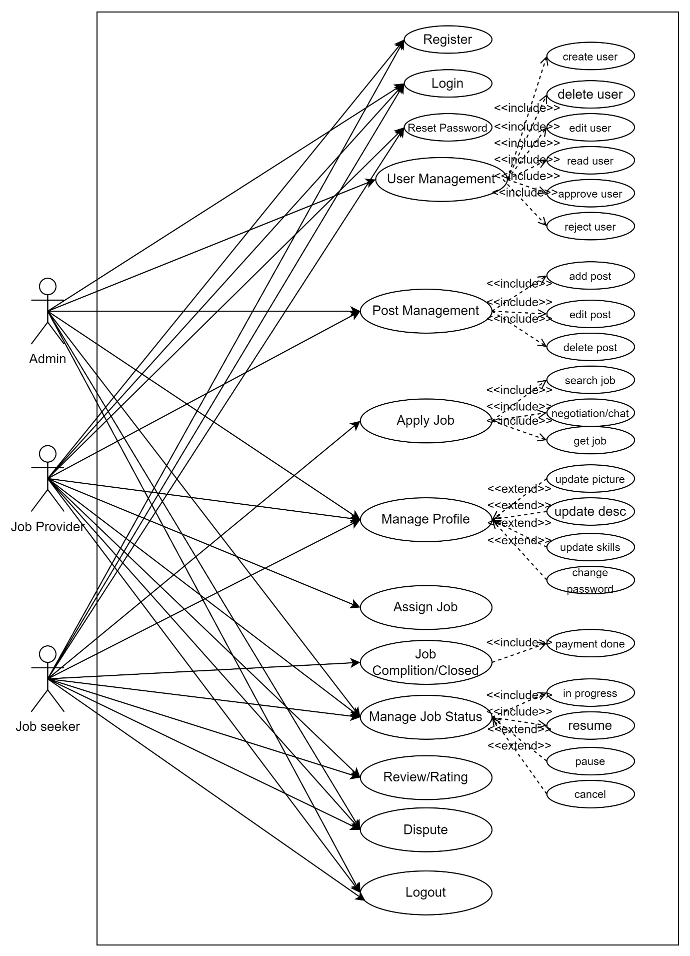

Fig 1: Use-Case E-LaborBridge

* Represents core functionalities of a job-based platform including login, profile, and job management.
* Uses **<<include>>** for mandatory sub-actions (e.g., add/edit post) and **<<extend>>** for optional features (e.g., update skills).
* Covers full workflow: register → apply/assign job → manage status → complete → review/dispute.
* Separates admin/user roles for actions like user and post management.

**Sequence Diagrams E-LaborBridge**

Fig 2: Sequence Diagram for Login

* **The system hashes the user's password and validates the credentials (username and hashed password) against the database.**
* **If the credentials are valid, the system generates an authentication token for the user.**
* **The user receives a response indicating whether the login was successful or failed, based on the validation and token generation process**

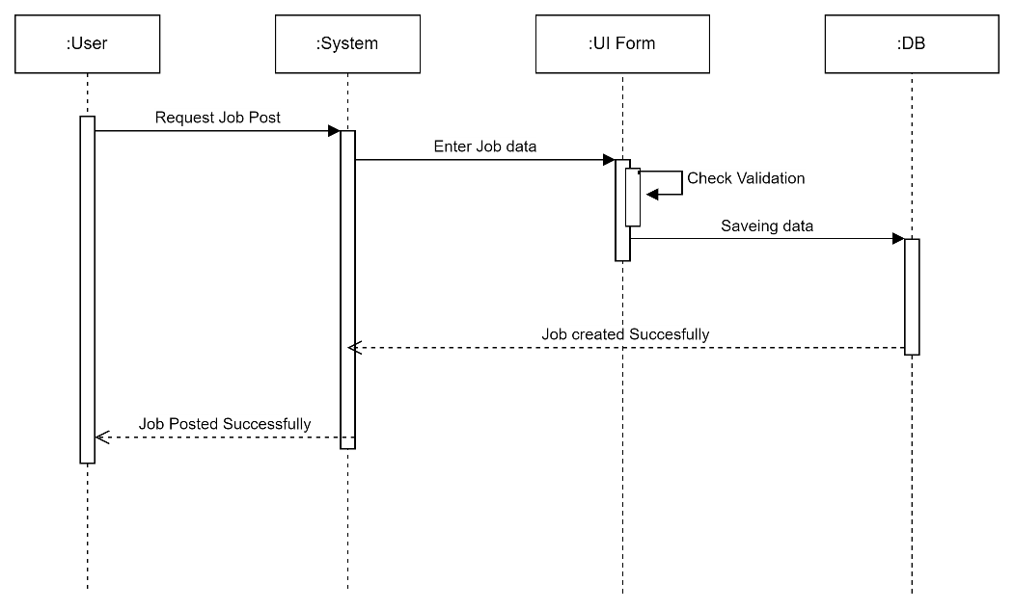

Fig 3: Sequence Diagram for job post

* **The user requests to post a job, and the system collects and validates the job data through the UI Form.**
* **After validation, the job data is saved to the database.**
* A screenshot of a computer

  AI-generated content may be incorrect.**The user receives a confirmation that the job has been posted successfully.**

Fig 4: Sequence Diagram for job post

* User sends a job search request to the system.
* System initiates negotiation/chat and messages are saved to the database.
* System responds to the user with job success or failure after negotiation/chat is done.

Fig 5: Sequence diagram for notification gets

* **User receives a job notification and sends a job request to the system.**
* **System saves the job in the database and waits for a success or failure response.**
* **System responds to the user with the result of the job request (success or failure).**

Fig 6: Sequence diagram for create user

* **User requests to create a new user.**
* **System validates and saves the user data to the database.**
* A screenshot of a computer

  AI-generated content may be incorrect.**User receives confirmation of successful user creation.**

Fig 7: Sequence diagram for status changing of job

* **User requests a job status change, which is processed by the system and UI.**
* **UI validates the request and updates the status in the database.**
* **System notifies the user that the status was updated successfully.**

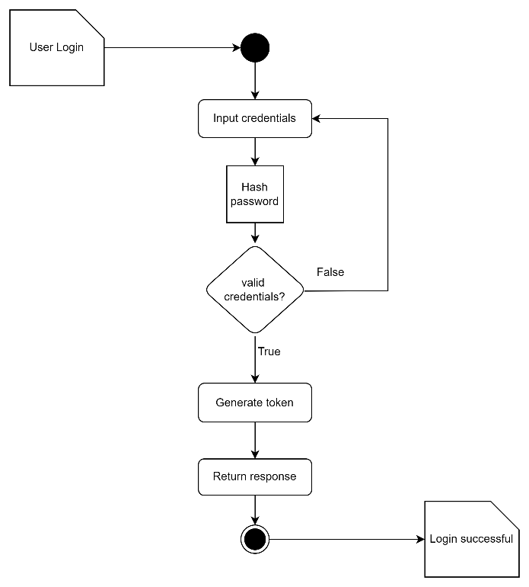**Activity Diagrams E-LaborBridge**

Fig 8: Activity diagram for Login

* **User enters credentials, which are hashed and validated.**
* **If credentials are valid, a token is generated.**
* **System returns a response, completing the login process.**

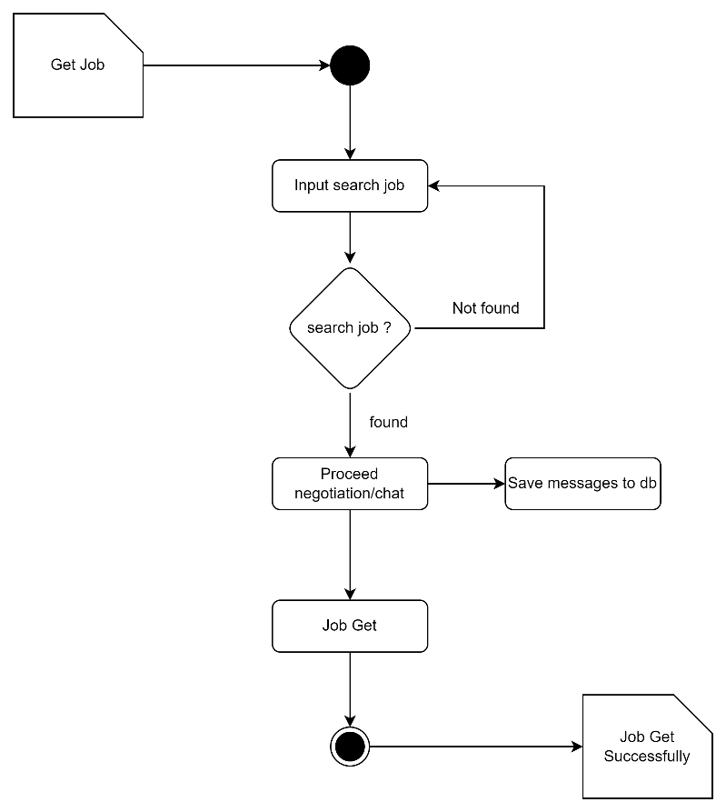

Fig 9: Activity diagram for job gets

* **User searches for a job; if not found, they can try again.**
* **If a job is found, negotiation or chat proceeds, and messages are saved to the database.**
* **Upon successful negotiation, the job is obtained, and the process completes.**

Fig 10: Activity diagram for post job

* User initiates the process by posting a job and entering job details.
* The system checks the entered details for validation; if validation fails, the user must re-enter the details.
* Once validated, the job is saved to the database and marked as posted successfully

Fig 11: Activity diagram for create user

* User enters details, which are then validated for correctness.
* If validation fails, the user must re-enter the details; if successful, the data is saved to the database.
* Upon successful saving, the system confirms that the user has been created successfully.

Fig 12: Activity diagram for job status change

* User selects a new job status, which is then validated for correctness.
* If validation passes, the new status is updated in the database.
* The system confirms the job status has been changed successfully.

**Class Diagram E-LaborBridge**

* The system uses a class inheritance structure where User is the base class, and JobSeeker, JobProvider, and Admin are specialized user types with their own functions and attributes.
* Job management is central, with the Job class tracking status, assignments, pauses, and completion, and connecting to applications, reviews, and disputes.
* JobProvider can post, edit, and assign jobs, while JobSeeker can apply, confirm, and complete jobs; both interact through negotiation and assignment confirmation processes.
* Real-time communication is supported via Conversation and Message classes, allowing users to chat and even request jobs directly through chat.
* Quality control and feedback are handled through Review and Dispute classes, enabling users to submit reviews and resolve conflicts related to jobs.

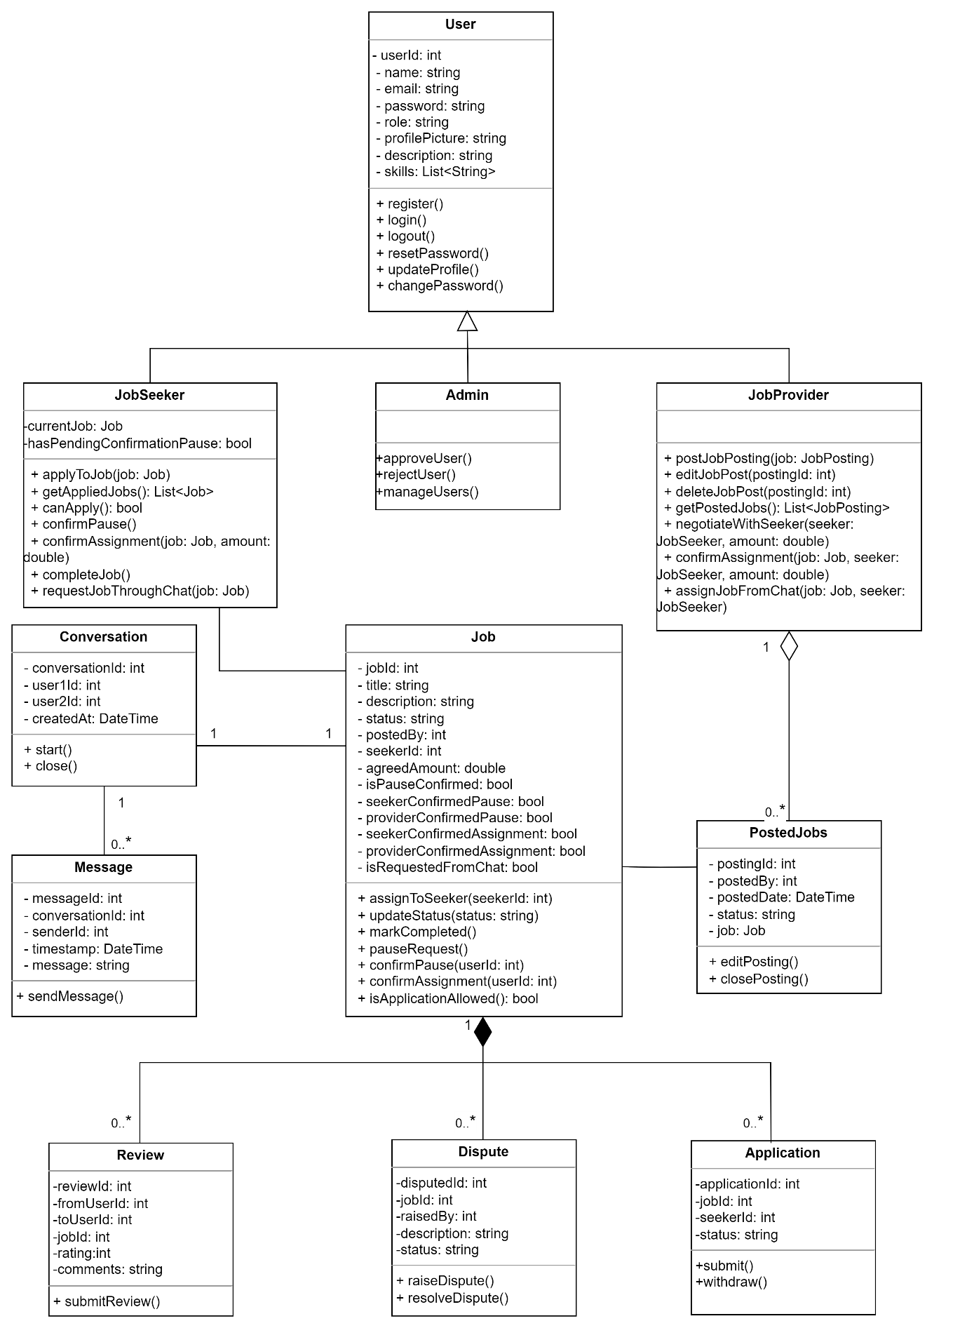

Fig 13: Class diagram of E-LaborBridge